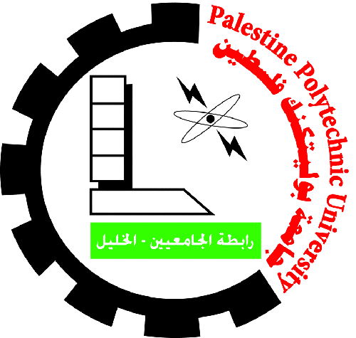

Palestine Polytechnic University

Faculty of Medicine and Health Sciences

Program of Healthy and Therapeutic Nutrition

Evaluation Form

Graduation Projects

Project Title: ……………………………………………………………………………

Project Supervisors: ……………………………………………………………………

Examiner Name: ………………………………………………………………………

Student name:…………………………………………………………………………

|  |  |  |
| --- | --- | --- |
| Score | Grade | Evaluation Criteria |
|  | 50 | Report (Thesis) |
|  | 15 | Presentation |
|  | 20 | Analysis and interpretation of results and discussion |
|  | 15 | Evaluation by supervisor |
|  | **100** | **Total average** |
|  |  |  |

Examiner Signature: ………………………… Date: ……………………